WxDE User Interface Design

|  |
| --- |
| The purpose of this document is to describe the current WxDE user interface and identify any planned changes to that user interface. |

Contents

General WxDE User Interface Elements 2

WxDE General Look and Feel 2

WxDE Menu 2

WxDE User Interface Pages 4

Home Page 4

Data Menu Option 5

Data Map 5

Observations – Contributor 13

Observations – Coordinate 18

Data Subscriptions 22

Data Menu Option 23

Metadata 23

Files 23

Tables 24

About Menu Option 26

News Page 26

Change Logs Page 27

Terms of Use Page 28

FAQ Page 28

Feedback Menu Option 29

Admin Menu Option 30

Feedbacks 30

Reports 31

Full Data Map 32

User Menu Options 32

Login 32

User Registration Page 34

Logout 35

# General WxDE User Interface Elements

## WxDE General Look and Feel

Each page on the site consists of a header, a menu bar, a content area, and a footer. One of two headers is used: a large header and a small header. The larger header, consists of the standard FHWA header with a Weather Data Environment sub-header underneath it, as shown below with the menu bar underneath the large header.

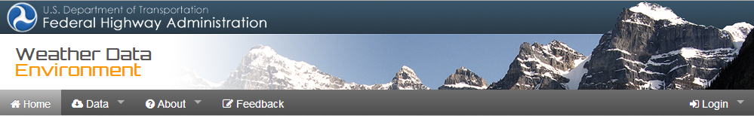

Updated: 4/2/2014

A small header is used in screens were more space is needed for the content area. The small header consists of the standard FHWA header with the words “Weather Data Environment” in the blank area of the standard FHWA header, as shown below.



Updated: 4/2/2014

We set up the system to use a large and small footer. The large footer is shown below and duplicates that used on the FHWA website, as shown below.



Updated: 4/2/2014

The small footer is shown below. Note that, in order to satisfy USDOT web policies, the small footer is currently configured to be identical to the large footer.



Updated: 4/2/2014

## WxDE Menu

The WxDE uses a consistent set of menu items, so that menu items always follow the same organizational structure and each menu item always results in the same action. However, different menu items are available on different screens. The table below lists the menu options and identifies the resulting action. The descriptions of each screen will identify the menu options that are available for each screen.

| Menu Item | Resulting Action |
| --- | --- |
| Home | Go to the WxDE Home Page. |
| Data | Activate a drop-down list of data-related menu items (see below) |
| Data Map | Go to the Data Map Page. |
| Observations | Activate a sub-menu listing menu items for querying data. |
| Contributor | Go to the Contributor Query Page – only available to users that log in. Users that do not log in are taken to the Login Page with an option to register with the WxDE. |
| Coordinates | Go to the Coordinate Query Page – only available to users that log in. Users that do not log in are taken to the Login Page with an option to register with the WxDE. |
| Data Subscriptions | Go to the Data Subscriptions Page – only available to users that log in. Users that do not log in are taken to the Login Page with an option to register with the WxDE. |
| Metadata | Activate a sub-menu listing menu items for viewing metadata |
| Files | Go to the Metadata Page contain metadata files – only available to users that log in. Users that do not log in are taken to the Login Page with an option to register with the WxDE. |
| Tables | Go to the Data Source Page contain contributor information – only available to users that log in. Users that do not log in are taken to the Login Page with an option to register with the WxDE. |
| Community | Activate a drop-down list of menu items related to the road weather community. Note that this menu item is currently not present in the WxDE while the desired content is being identified and developed. |
| WxDE Reports | Go to the WxDE Reports Page, which will list reports related to the WxDE (e.g., reports on the WxDE, reports developed using WxDE content). This page is not yet available and USDOT has not yet confirmed that they want this page developed. |
| Discussion Groups | Go to the Discussion Groups Page. This page will host discussion groups related to the WxDE and road weather management. This page is not yet available and USDOT has not yet confirmed that they want this page developed. |
| External Links | Go the External Links Page. This page will list external links related to the WxDE and road weather management and provide hyperlinks taking users to those external links. This page is not yet available and USDOT has not yet confirmed that they want this page developed. |
| About | Activate a drop-down list of menu items related to information about the WxDE. |
| News | Go to the News Page. |
| Change Logs | Go to the Change Logs Page. |
| Terms of Use | Go to the Terms of Use Page. |
| FAQ | Go to the FAQ Page. |
| Feedback | Go to the Feedback Page, initialing the page with information in the Section field about the page that was active when the Feedback menu item was selected. |
| Admin | Activate a drop-down list of menu items that provide access to administrative reports. This menu option is only visible to users logged in with Super User privileges. |
| Feedbacks | Go to the Feedbacks page, which lists the feedback that has been submitted. |
| Reports | Go to the Reports Page. This page lists WxDE documents, which the user can access by clicking on a document of interest. |
| Full Data Map | Go to the Google Map view with all platforms displayed |
| Login | Go to the Login Page. This item also activates a drop-down list of menu items. Note that this item is only visible if the user has not logged in. Otherwise, the Login item is replaced with the User Name item. |
| Registration | Go to the Registration Page. |
| User Name | Activate a drop-down list of menu items. Note that this item is only visible if the user has logged in. Otherwise, the Login item is visible instead. |
| Manage | Go to the User Management Page. |
| Logout | Log out the user and return to the Home Page. |

In general, all menu options are available on every page in the WxDE. Exceptions to this general rule are noted in the descriptions of the individual pages.

# WxDE User Interface Pages

The following sections describe WxDE user interface pages.

## Home Page

The WxDE Home Page introduces the user to the WxDE. A screenshot is pictured below.



Updated: 4/2/2014

The upper left graphic element cycles through a series of weather-related images. The box at the upper right cycles through a series of recent news items related to road weather, some of which include hyperlinks for more information. The box at the bottom contains static text describing the WxDE.

## Data Menu Option

The Data menu option provides access to several features related to WxDE data, including a map displaying WxDE data, wizards for querying and creating subscriptions for WxDE data, a page for accessing WxDE subscription data, and a list of available WxDE metadata. Each of these is described in detail below.

### Data Map

The Data – Data Map menu option access a map displaying WxDE observations. The user is first presented with an introductory page that shows the locations for which data is available and allows a user to select a location. When the user selects a location, a different map is displayed that is zoomed in to the selected location and includes the WxDE observations in the map display.

The Data Map Page

The Data Map Page is an introductory page that serves four purposes: (1) it shows the coverage extent of WxDE data (2) it displays the alert symbol on states that had a collection problem from the previous day (see Iowa for illustration purpose) (3) it allows the user to hover the mouse over a State (see Minnesota in the map below) to bring up an info window in the lower right corner showing data collection status from the previous day and (4) it allows the user to click on a State to bring up the Observation Map Page focused in on the selected State. The last use is particularly valuable because displaying the Observation Map Page fully zoomed out can be slow due to the large amount of data that must be displayed. Note the collection status shown on this page provides a quick cursory view. For detailed status information, a user with Admin privilege can log in first and then use the Admin -> Reports page to download a CSV file containing such information.

The content area of the Data Map Page is pictured below.

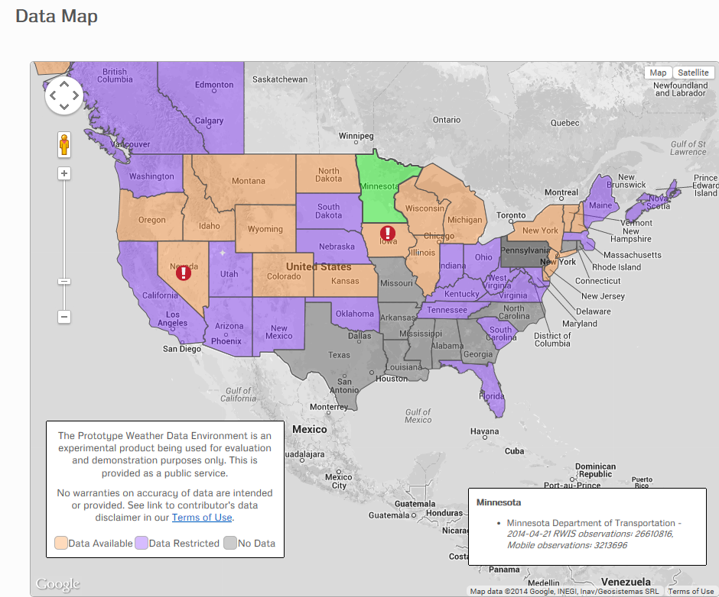

Updated: 4/22/2014

A user can click on a State to go the Observation Map page, zoomed in to the selected State. Clicking on the Terms of Use hypertext takes the user to the Terms of Usage Page.

The Observation Map Page

The Observation Map Page displays the locations at which observation data are available. This page is presented via the Google Map API, so consists of a Google Map overlaid with dots for the observation locations. Most of the functionality is inherited from Google Maps – click-and-drag or click the pan button to pan the map, click on the zoom bar or use the wheel on the mouse to zoom in and out, and click the map and satellite buttons to toggle between a map and satellite imagery view. The WxDE-specific elements of this page are:

* The Home text is a hyperlink that returns the user to the WxDE Home Page.
* The “(Re-center map on …)” drop-down box allows the user to re-zoom to the selected region.
* The Platform Code text box indicates the platform name when the user hovers the mouse over a platform.
* The Lat, Lon text at the upper right corner lists the latitude and longitude of the current mouse position.
* The “(Select Data to Show)” drop-down box allows the user to select which observation type to display on the map. When selected, the latest observation for the indicated observation type is displayed next to each platform location.
* The Metric / English switches between metric and English units for the observations displayed via the “(Select Data to Show)” drop-down box.
* The Road Segments, VDT Mobile, WxDE Mobile and Non-mobile check boxes allow the user to indicate whether to include combinations of different platforms on the map.
* The time text at the lower right corner displays the current UTC time.
* When the user hovers the mouse over a mobile platform, a yellow trail will show up representing the path the vehicle has travelled in the past hour. The user may need to zoom in close enough to see the trail.
* When the user clicks on a platform or a road segment, a sidebar by default is displayed with recent observations for that platform / road segment. The user has the option to switch to the info window or the sidebar display by clicking the InfoWindow or Shade button next to the “(Re-center map on …)” drop-down box.

The following screenshots show the various platforms on the map.

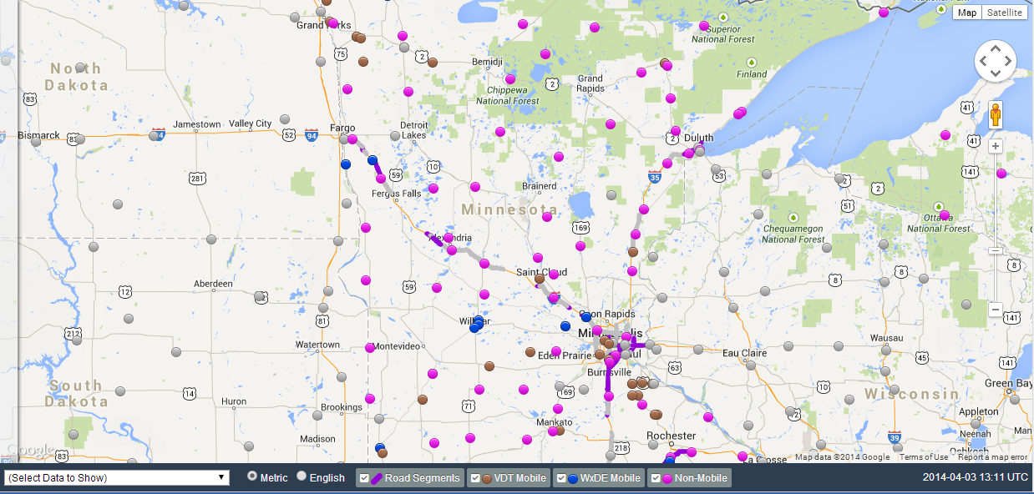

Updated: 4/3/2014

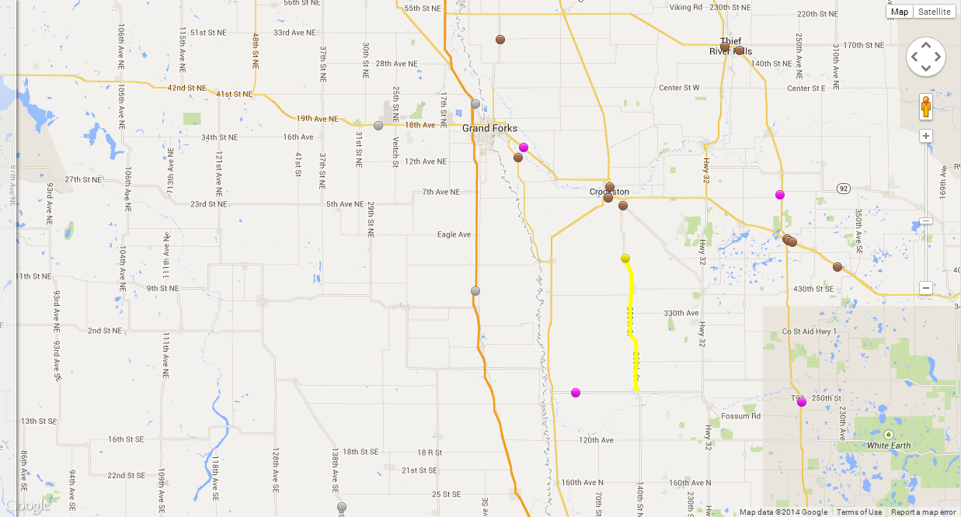

Trail for Mobile Vehicle (Updated: 4/3/2014)

Observation Table

The WxDE Observation Table can be shown in either the sidebar or the info window. This table is used to display recent observations from a selected platform. It is a table that lists observations, sorted by observation type and time for non-mobile platforms and sorted by time for mobile platforms. The observed values are displayed, along with the quality check information for each observation. Three different versions of this table are used, which differ primarily according to the columns that are displayed. The three versions are described below.

**WxDE Platform Observation Table**

The WxDE Platform Observation Table displays data from fixed and mobile platforms that are received directly by the WxDE (i.e., labelled as “WxDE Mobile” and “Non-mobile” on the WxDE Data Map Page). The table includes the observations from that platform and the WxDE quality check values computed for each observation. When the table is displayed in the sidebar view, it is translucent by default until the user hovers the mouse inside it, at which time the sidebar becomes opaque. Below are screenshots of both the sidebar and the info window. 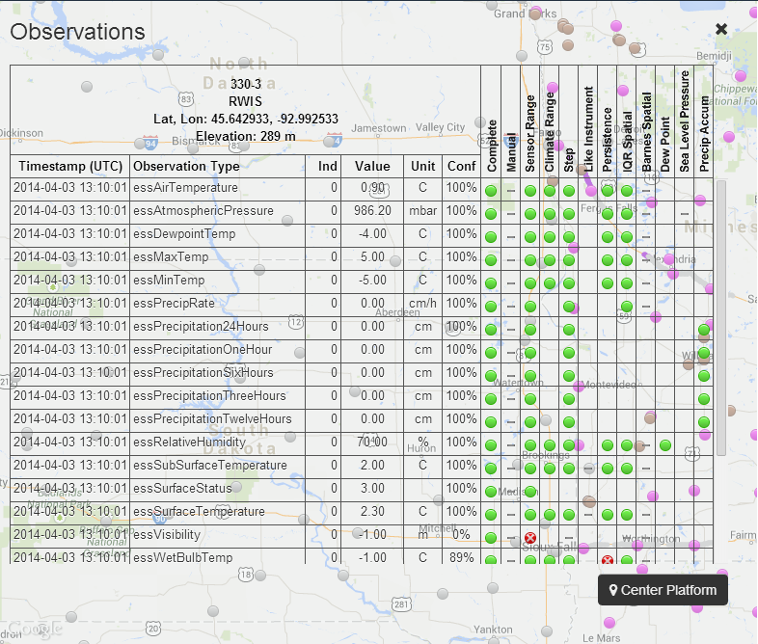

Translucent Sidebar (Updated: 4/3/2014)

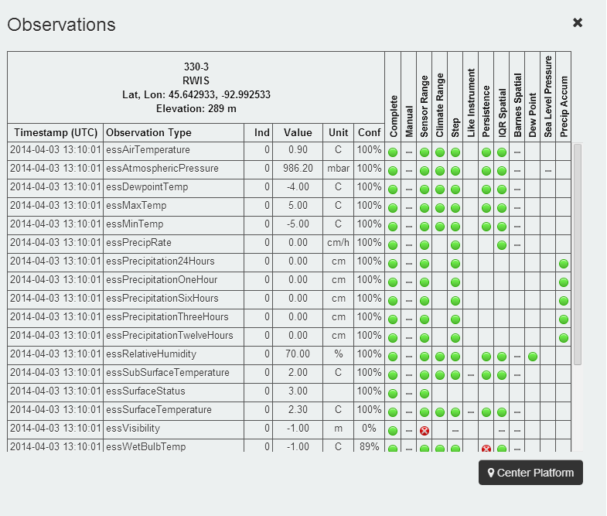

Opaque Sidebar (Updated 4/3/2014)

The Center Platform button in the sidebar allows the selected platform to be placed at the center of the map. While the sidebar is displayed, the user can also pan the map if the selected platform is hidden behind the sidebar.

If the selected platform is mobile and a yellow trail is being displayed, the user can highlight different data rows in the observation table by hovering mouse on these rows and then scrolling up and down to observe how the mobile platform (represented by a black circle) moves along the trail accordingly.

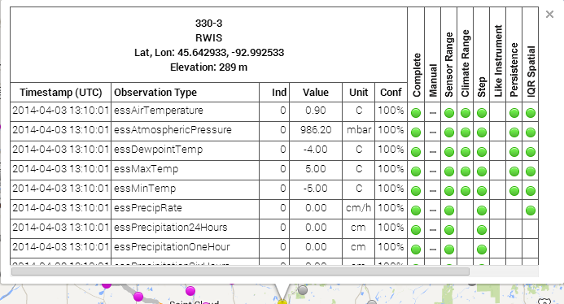

Info Window (Update 4/3/2014)

VDT Platform Observation Table

The second table is similar, but is for data from mobile platforms after processing by the VDT to apply VDT quality checks to the data. A screenshot of this table is shown below.

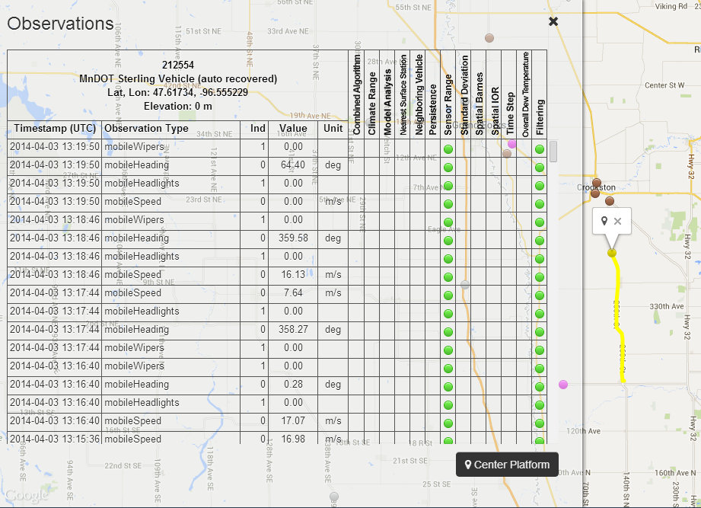

Updated: 4/3/2014

VDT Road Segment Observation Table

The third table is for data computed by the VDT for road segments. It includes statistical averages of observations along each road segment and assessments of conditions along the selected road segment, as shown below.

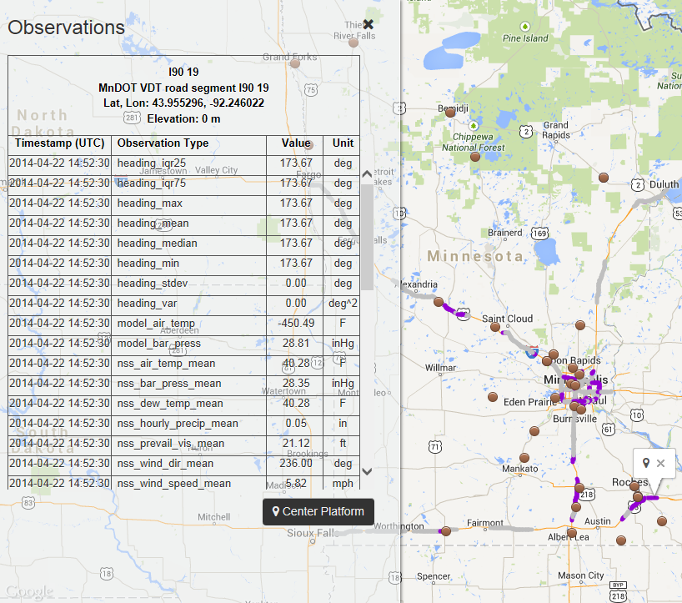

Updated: 4/22/2014

### Observations – Contributor

The Data – Observations – Contributor menu option brings up the Contributor Query Wizard, which helps a WxDE user select observations by first selecting a collection of platforms for which observations should be downloaded. The wizard consists of the following steps:

1. Select one or more contributors from a list of WxDE contributors.

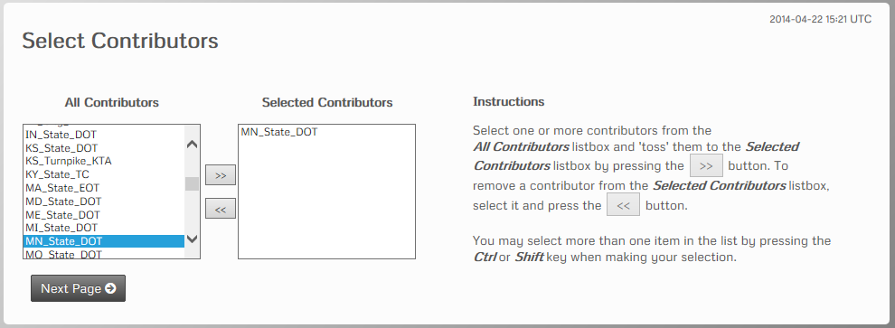

Updated: 4/22/2014

The user selects contributors from the list on the left using standard selection methods (e.g., click to select one, ctrl-click to select another, shift-click to select a series of contributors), then clicks on the “>>” button to add the contributors to the list on the right. Contributors can be removed from the right list in a similar manner.

1. Select one or more platforms from the list of platforms associated with the selected contributors.

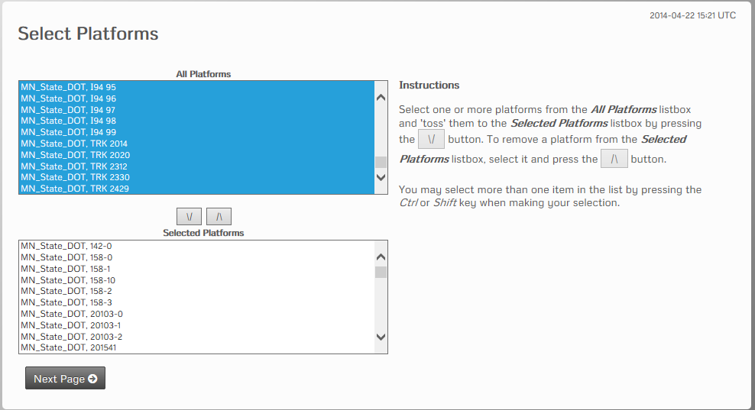

Updated: 4/22/2014

The selection process is similar to that used for contributors, but with boxes above and below instead of left and right.

1. Select observation types for the observations that will be returned.

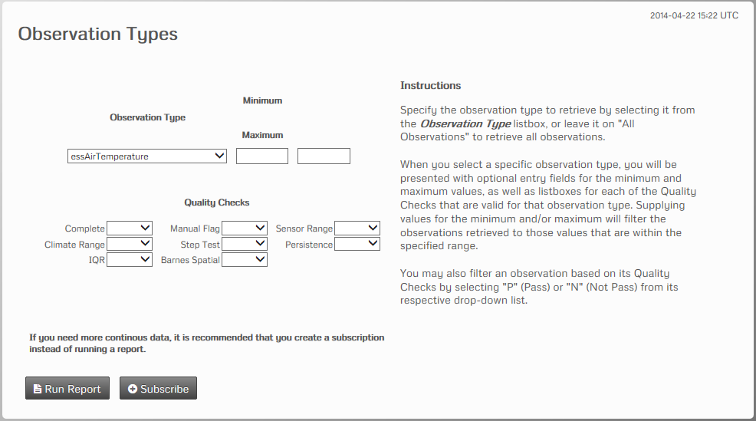

Updated: 4/22/2014

The user can either (a) request all observation types or (b) request a single observation type. If they select a single observation type, they can also place constraints on their request based on that observation type by specifying a minimum and maximum value for the observations returned and/or quality check results. Clicking on Run Report goes to the next step in specifying the query. Clicking on Subscribe goes to the next step in creating a subscription.

Additional steps for creating a query

1. Select a date range for the observations to be returned and a data format.

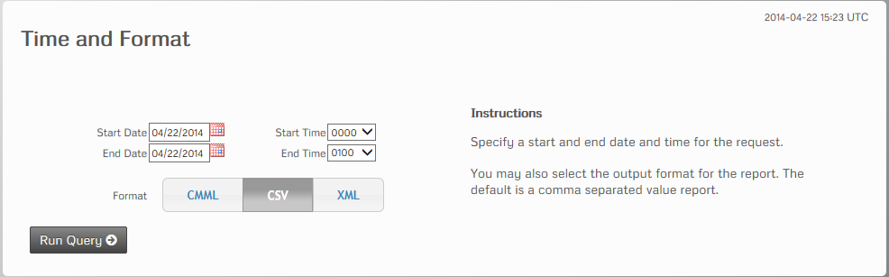

Updated: 4/22/2014

The user must specify a start and end date for the request and a format for the results returned, then click the Run Query to run the query.

1. Return the results.

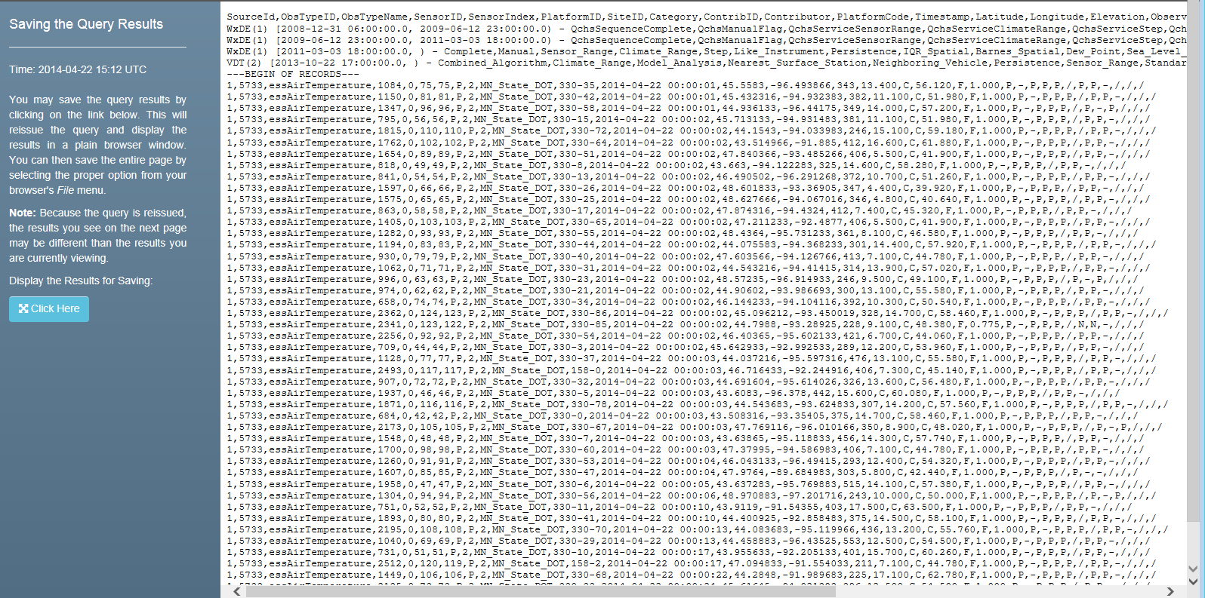

Updated: 4/22/2014

The results are returned in the selected format.

Additional steps for creating a subscription

1. Specify final subscription parameters and enable the subscription.

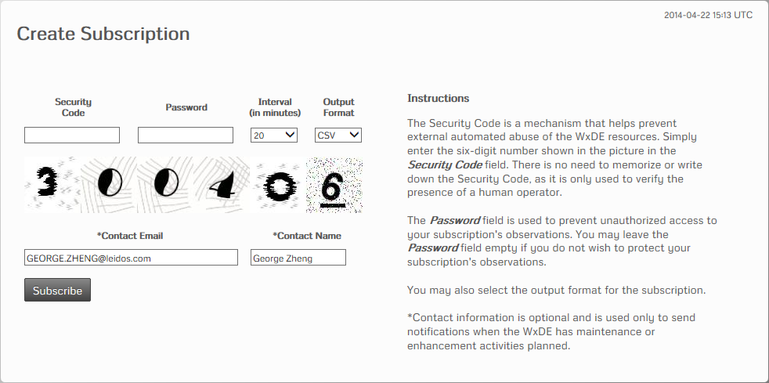

Updated: 4/22/2014

The user specifies the security code, an optional password for accessing the resulting data, a data generation frequency, and an output format. The user must also specify a contact email and contact name. They then click on the Subscribe button to activate the subscription.

1. The WxDE displays information about the subscription and instructions for accessing it, as shown below.

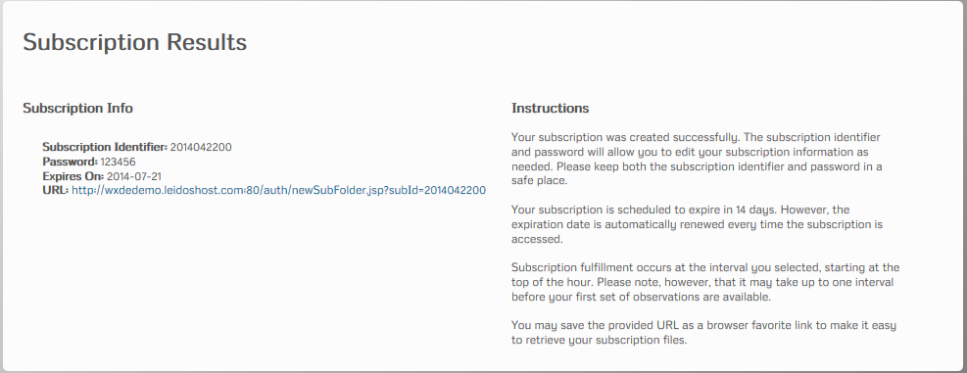

Updated: 4/22/2014

If the user clicks on the url, they proceed to Step 6 to view information about that subscription. Alternately, the user can select any other menu option to access other WxDE features.

1. The WxDE displays information about the subscription and the data files available for the indicated subscription, as shown in the screenshot below. Note that, initially, the list of data files available is empty because the initial subscription run will not have been completed.

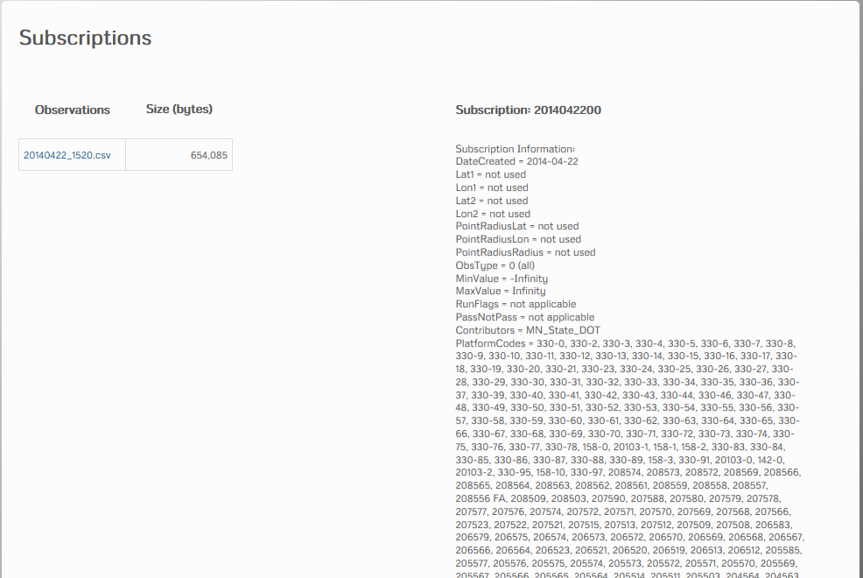

Updated: 4/22/2014

### Observations – Coordinate

The Data – Observations – Coordinates menu option brings up a wizard for creating a query or subscription in which the user requests data within a geographic region. The wizard consists of the following steps:

1. Select a geographic region of interest by specifying either a rectangular or circular region. The screen below is used to specify a rectangular region.

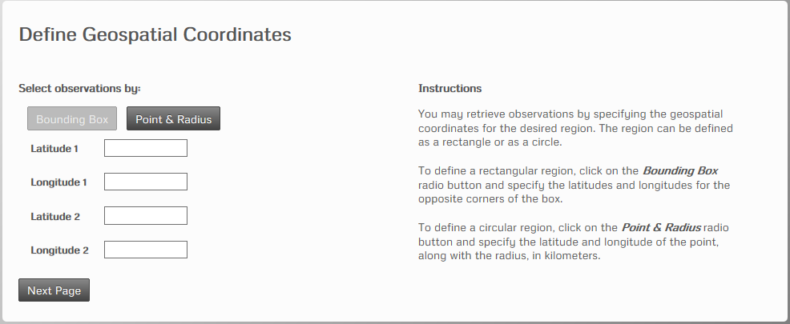

Updated: 12/31/2013

Alternately, the user can specify a circular region via the screen below.

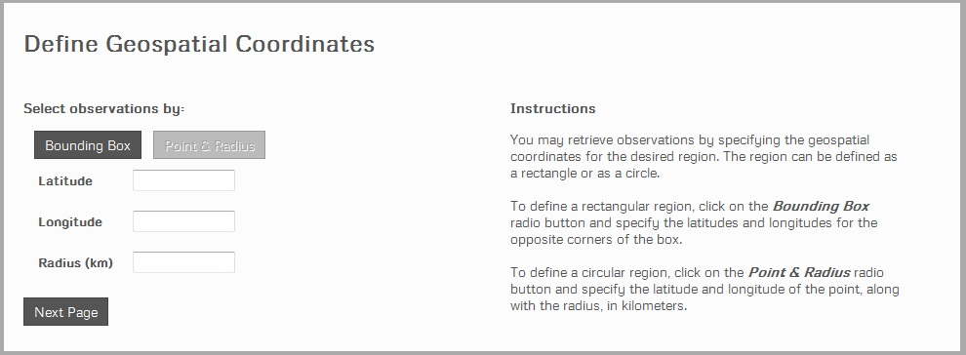

Updated: 12/31/2013

1. Select observation types for the observations that will be returned. The user can select “All Observations” (as shown in the figure below) to request all observation types.

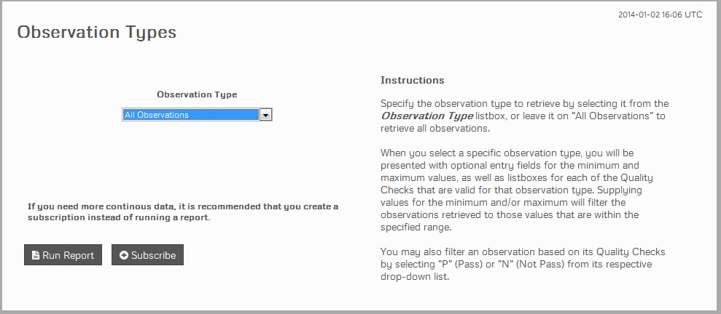

Updated: 12/31/2013

If the user selects a specific observation type, they can also specify filters to apply to the returned observations, so that only observations that pass the indicated filter criteria are returned. The following filter options are available:

* Specify a minimum and/or maximum value to exclude values that lie below the minimum value or above the maximum value.
* For each quality check that is applied to the selected observation type, either (a) select a quality check value to filter by that quality check value or (b) leave blank to not filter by the specified type of quality check.

A screenshot of this step is shown below.

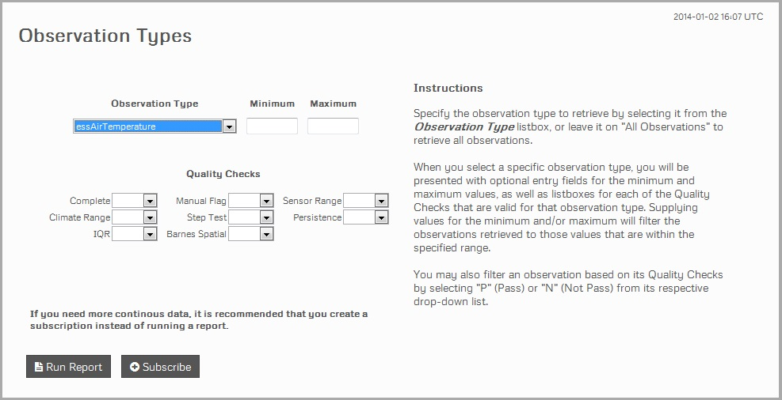

Updated: 12/31/2013

Clicking on Run Report goes to the next step in specifying the query. Clicking on Subscribe goes to the next step in creating a subscription.

Additional steps for creating a query

1. Select a date range for the observations to be returned and a data format.

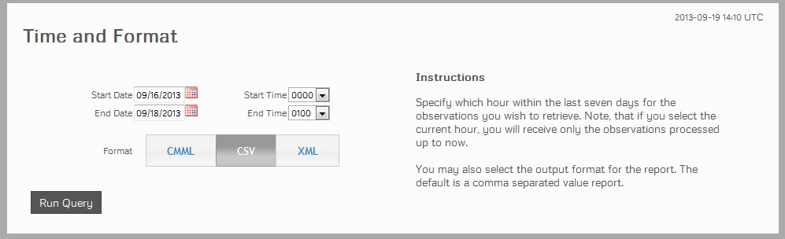

Updated: 9/16/2013

The user must specify a start and end date for the request and a format for the results returned, then click the Run Query to run the query.

1. Return the results.

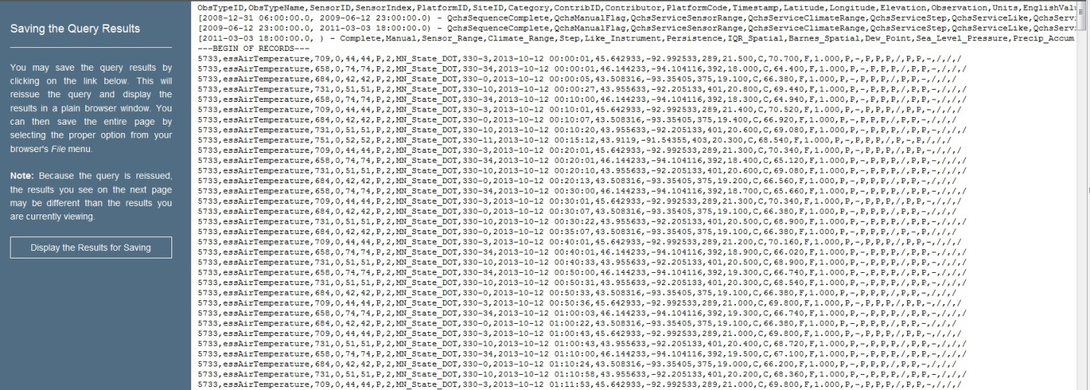

Updated: 10/14/2013

The results are returned in the selected format.

Additional steps for creating a subscription

1. Specify final subscription parameters and enable the subscription.

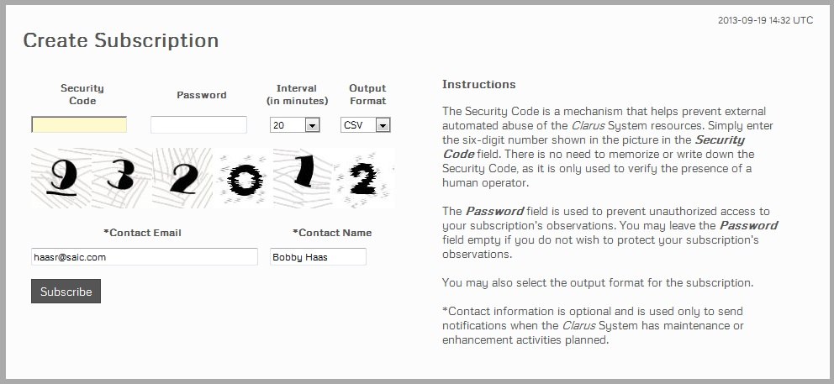

Updated: 9/16/2013

The user specifies the security code, an optional password for accessing the resulting data, a data generation frequency, and an output format. The user must also specify a contact email and contact name. They then click on the Subscribe button to activate the subscription.

1. The WxDE displays information about the subscription and instructions for accessing it, as shown below.

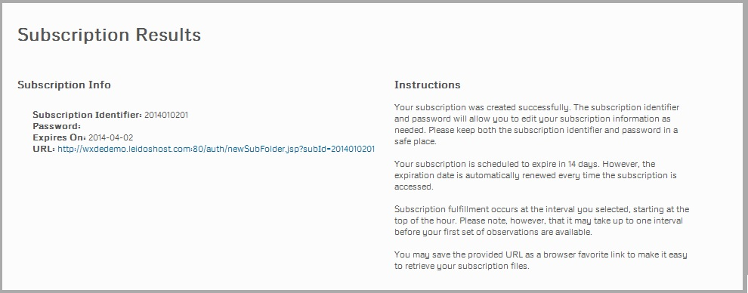

Updated: 12/31/2013

If the user clicks on the url, they proceed to Step 5 to view information about that subscription. Alternately, the user can select any other menu option to access other WxDE features.

1. The WxDE displays information about the subscription and the data files available for the indicated subscription, as shown in the screenshot below. Note that, initially, the list of data files available is empty because the initial subscription run will not have been completed.

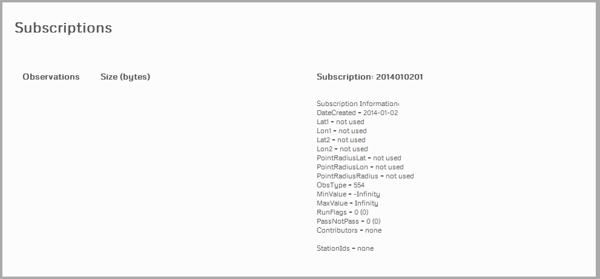

Updated: 12/31/2013

### Data Subscriptions

The Data – Data Subscriptions menu option accesses a page that lists subscriptions that are currently active, as shown below.

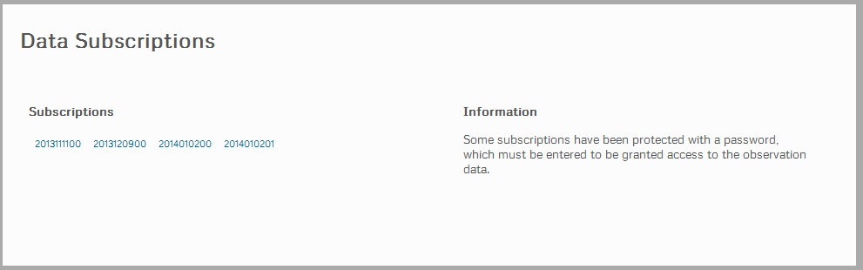

Updated: 12/31/2013

The user can click on a subscription to access the data generated for that subscription. If the subscription is password protected, the user is asked to enter a password, as shown below.

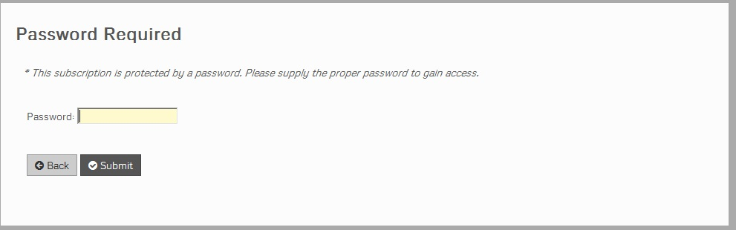

Updated: 12/31/2013

If the user enters an incorrect password, a message is displayed at the bottom of the screen stating “Incorrect password.”, and the user can re-enter the password. If the user enters the correct password, a screen is displayed that provides information about the selected subscription and lists the subscription data files available.

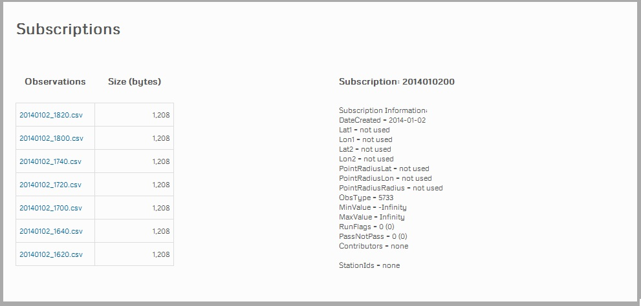

Updated: 12/31/2013

The user can download a subscription file by clicking on the subscription file name.

## Data Menu Option

The Data menu option provides access to several features related to WxDE data, including a map displaying WxDE data, wizards for querying and creating subscriptions for WxDE data, a page for accessing WxDE subscription data, and a list of available WxDE metadata. Each of these is described in detail below.

### Metadata

The Metadata menu option provides access to the metadata files page and the metadata tables page. Each of these is described in detail below.

### Files

The Files page, shown below, is used to access the comma-delimited metadata files. The page simply lists each metadata file and the date and time each file was most recently updated. Each metadata file is automatically updated each day so that the available metadata files always reflect the latest metadata, so the times listed in the “Last Updated” column are always within the last 24 hours. Clicking on a file name opens the file for viewing in the user’s browser. A user can download a metadata file by clicking on the Download button next to the file.

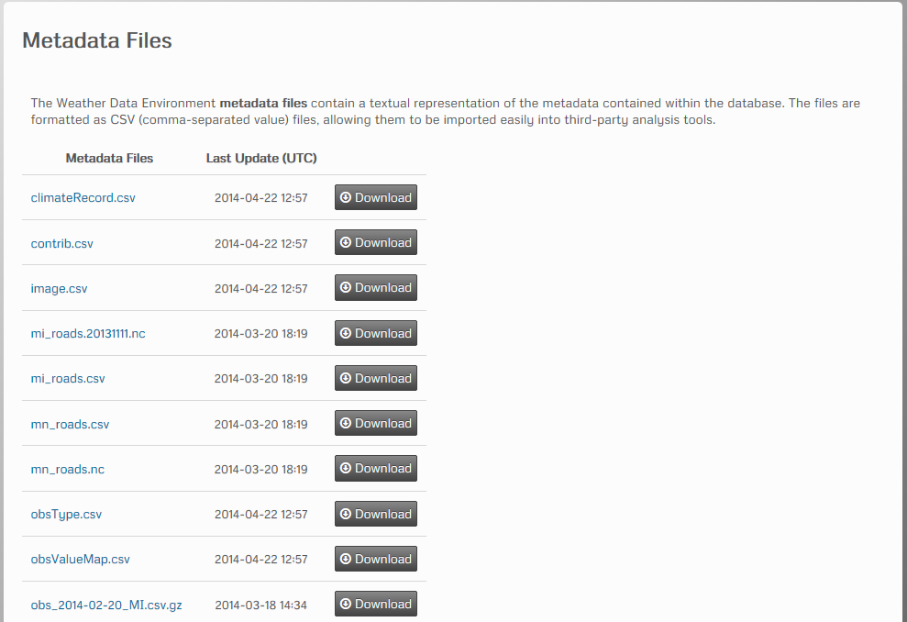

Updated: 4/22/2014

### Tables

The Files pages, shown below, are used to access the metadata in a more graphic fashion. Two table pages currently provided are the Data Source page and the Platform page.

The Data Source Page provides information about the sources providing data to the WxDE, including links to disclaimer information related to specific data sources. The page consists of two areas:

* A header area that describes the filters related to the data source metadata being displayed (e.g., the effective date, any filters applied to the list of data sources)
* A table that lists the data source metadata

The data source metadata table lists the following information for each source:

* Data source name
* Name of agency providing the data
* A hyperlink to disclaimer information (if there is a disclaimer associated with this data source)
* A hyperlink to platform information for this data source.

The look-and-feel of the page is shown below

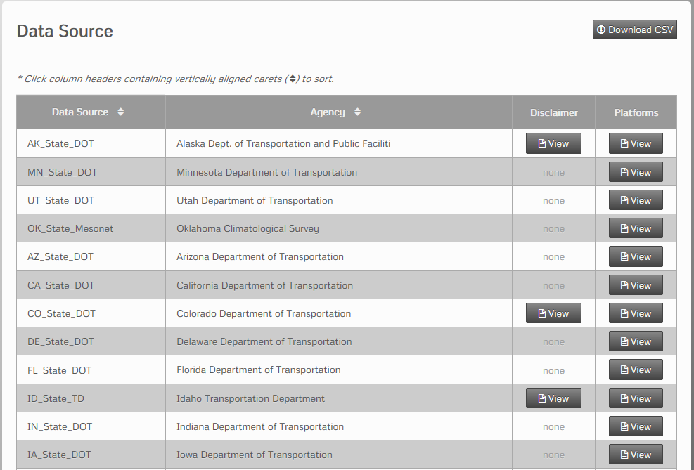

Updated: 4/22/2014

Clicking on the Data Source or Agency column header will sort the entries by that column. Clicking on a “view” entry will bring up a page that displays the related information –a disclaimer message for the Disclaimer column or the Metadata – Platforms page for the Platforms column. The user can also download the metadata of the list of data source in CSV format by clicking the Download CSV button.

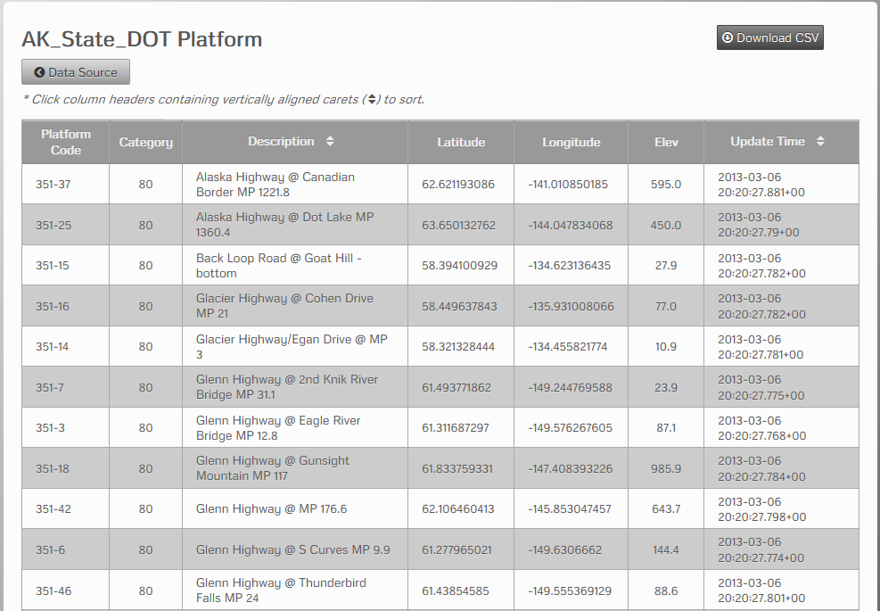

Updated: 4/22/2014

The user can download the corresponding metadata for the platform by clicking the Download CSV button.

## About Menu Option

The About menu option provides access to features that provide additional information about the WxDE, such as change logs describing changes to the WxDE, information about WxDE data sources, and frequently asked questions about the WxDE. These features are described in more detail below.

### News Page

The News page displays the history of the Latest News items listed on the Home Page, listing both the items currently displayed on the Home Page and other items previously displayed. A screenshot of the News Page is shown below.

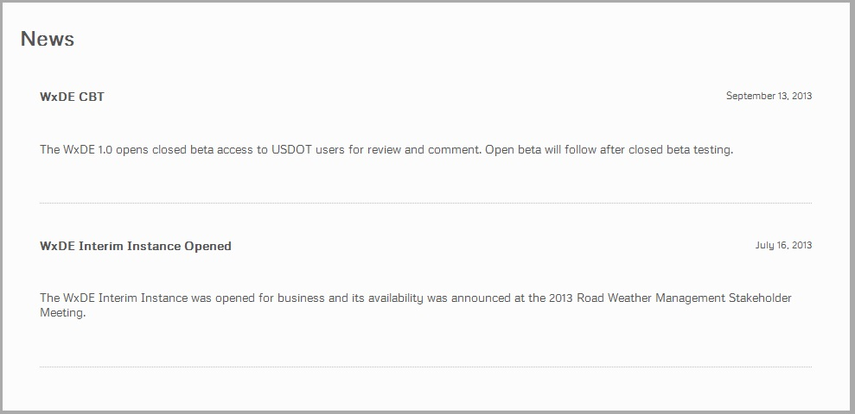

Updated: 12/31/2013

### Change Logs Page

The About – Change Logs menu option opens the Change Logs Page, which lists the history of changes to the WxDE. Each change log entry begins with the data of the change and continues with a bullet list that briefly describes the changes that were deployed on that date. An example of the Change Logs page is shown below.

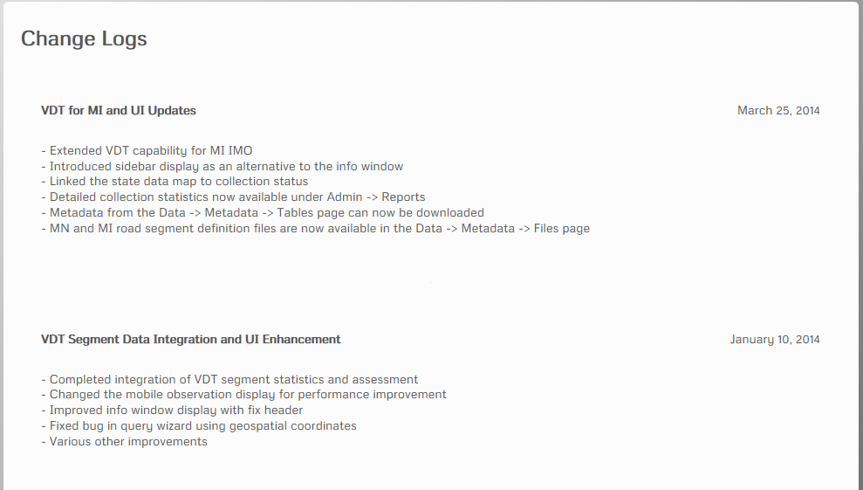

Updated: 4/22/2014

### Terms of Use Page

The Terms of Use Page lists the terms of use for the WxDE via a standard WxDE HTML content page, as shown in the figure below.

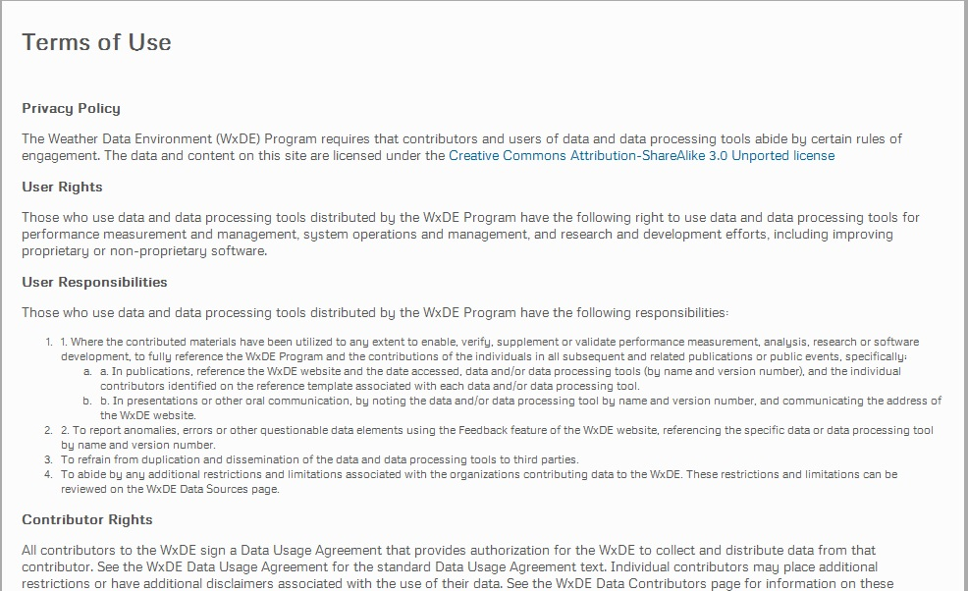

Updated: 12/31/2013

### FAQ Page

The FAQ page displays questions related to the WxDE and answers to those questions. The questions include questions about terminology used on the WxDE site, how to perform actions on the site, the importance of registering at the site, etc. The look-and-feel of the FAQ page is shown in the screenshot below.

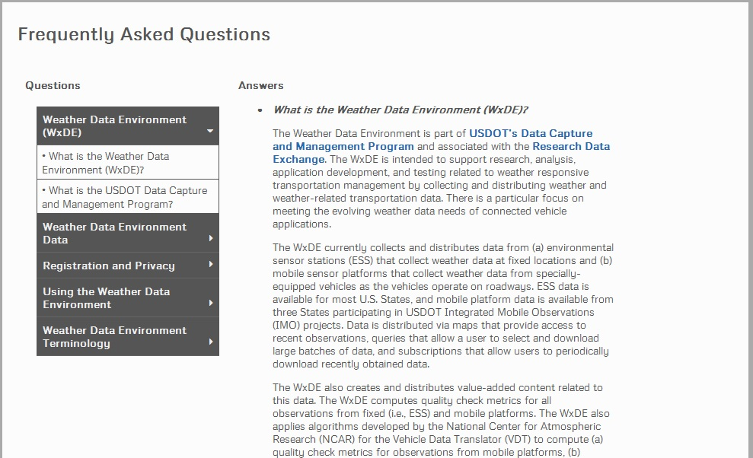

Updated: 12/30/213

The questions are listed on the left, divided into several categories. Clicking on open category closes that category. Clicking on a closed category closes any open category and opens the new category. Clicking on a question in a category moves to the indicated answer in the Answer panel.

The Question panel is configured so that the top of the Questions panel is always at the top of the visible page, making it easy for users to select a new question.

## Feedback Menu Option

The Feedback menu option access the Feedback page, which allows the user to submit feedback to the WxDE development team. Three types of feedback can be submitted: (1) feedback on an existing feature, (2) a request for a new feature, and (3) a bug report. The only differences between the screens used for these types of feedback are that, with the Bug Report, the user is asked to indicate the type of bug (i.e., user interface, data, or broken link). A screenshot of the Feedback Popup Screen is shown below.

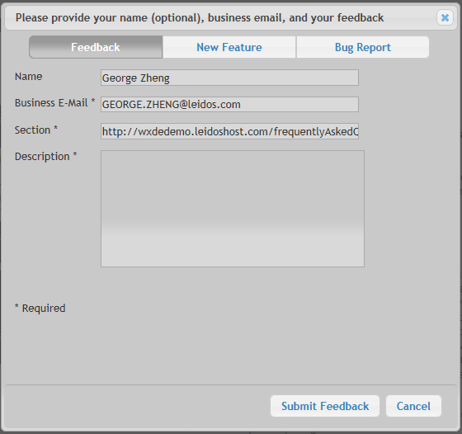

Updated: 4/22/2014

## Admin Menu Option

The Admin menu option provides WxDE users with administration privileges with access to additional WxDE features, such as the list of feedback that has been provided and WxDE documentation.

### Feedbacks

The Admin – Feedbacks menu option access the Feedbacks page, which lists Feedback that has been received from WxDE users. The page consists of a table that lists each feedback

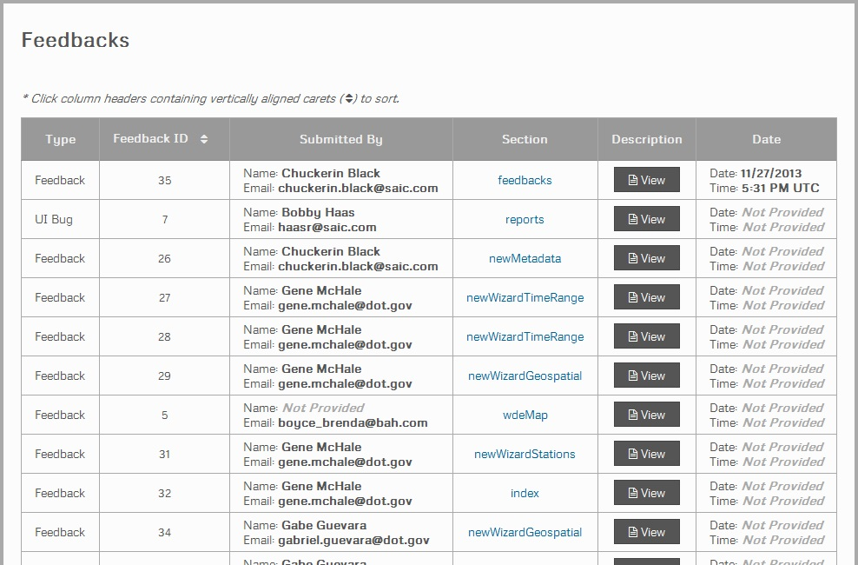

Updated: 12/31/2013

### Reports

The Admin – Reports menu option accesses the Reports Page, which lists WxDE documentation, such as Sprint Status documents and User Interface Development documents. A screenshot of this page is shown below.

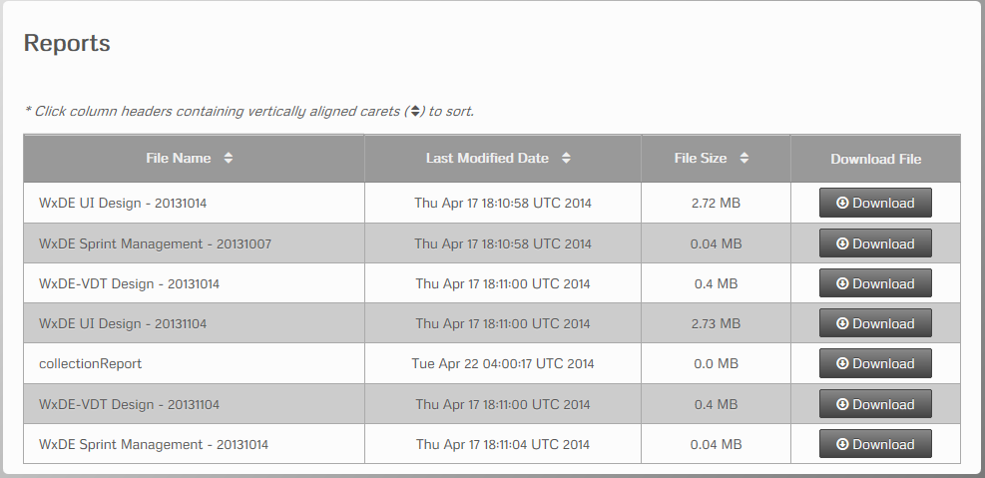

Updated 4/22/2014

The list of reports is taken from a directory and lists all documents in that directory by name, so adding a document to the directory automatically updates the page. One of these reports is collectionReport that gets updated on a daily basis. It contains data collection statistics from the beginning of the previous month. Document naming conventions will be used so that a series of related reports appear together on the page, as indicated above. The report also lists the Last Modified Date and File Size, and provides a Download button that can be used to download and view the document.

### Full Data Map

The Admin – Full Data Map menu option displays the data map with all platforms displayed, as shown in the screenshot below.

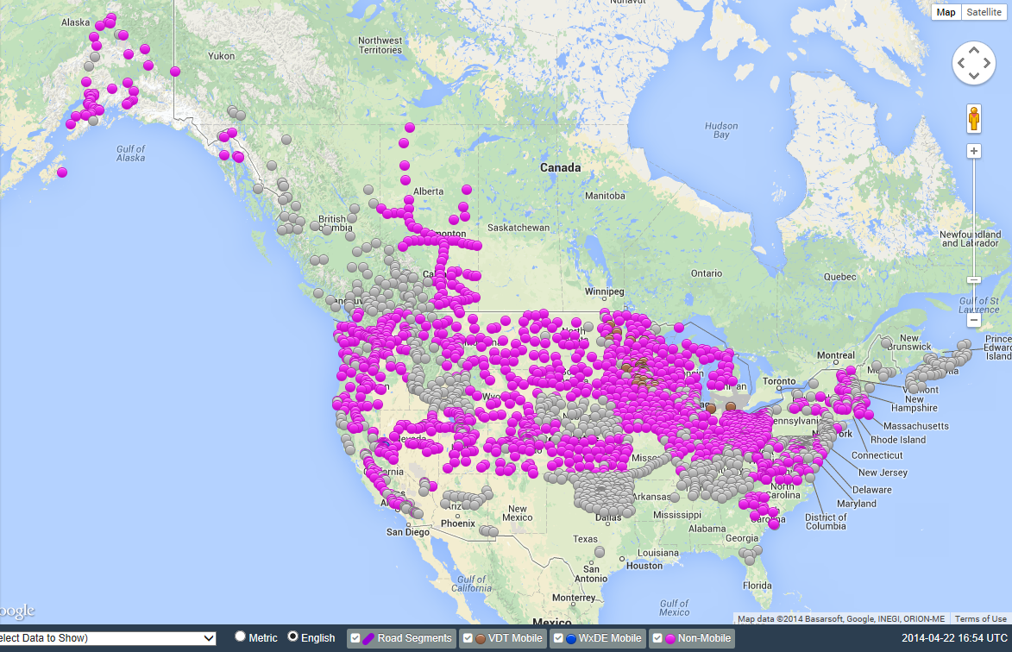

Updated 4/22/2014

## User Menu Options

The User menu provides access to features related to user management. If the user has not logged in, the user can either click on the Login menu option to log in or the Registration menu option to register with the WxDE. If the user has already logged in, the menu displays their user name and the available options are (a) Manage for editing their user account information and (b) Logout for logging out.

### Login

The User Login Page allows a user to log in to the WxDE. The user enters their user name and password and Clicks the Sign In button to log in. Alternately, the user can click the Register button to create a new user account or click the “Can’t access your account?” text to access the Retrieve Account Information wizard.

The User Login Page is shown below.

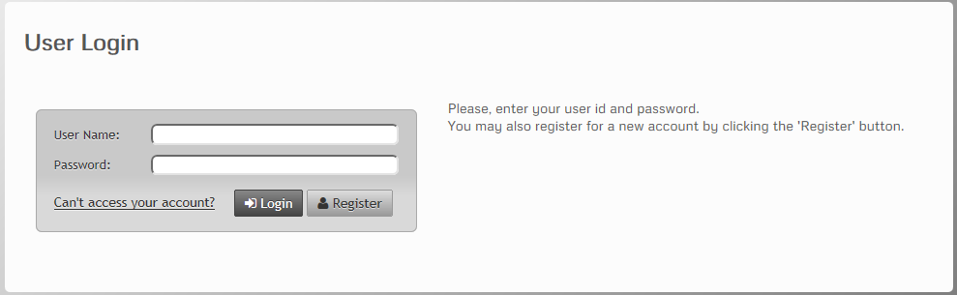

Updated: 4/22/2014

The User Login Failure Page is displayed when the user log in information is incorrect. It is pictured below.

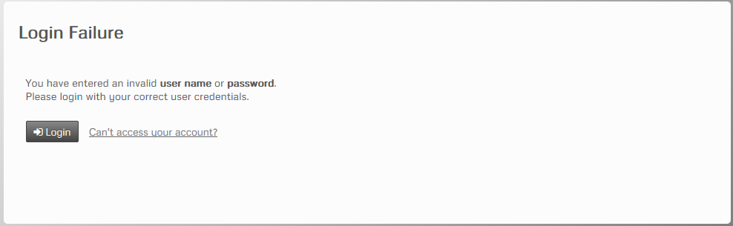

Updated: 4/22/2014

The user can click on the Login button to return to the User Login Page or click on the “Can’t access your account” hyperlink to access the Retrieve Account Information Wizard.

Retrieve Account Information Wizard

This wizard is used to help a user log in when they have forgotten their password or user name. The basic approach is identify the information that the user has forgotten and send them an email with the required information. The steps are:

1. Indicate if the password or user ID was forgotten.

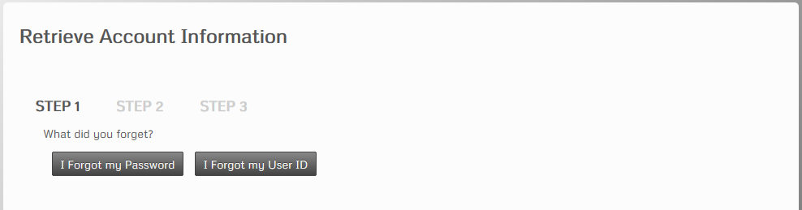

Updated: 4/22/2014

1. Enter the user’s email address and click the Submit button.

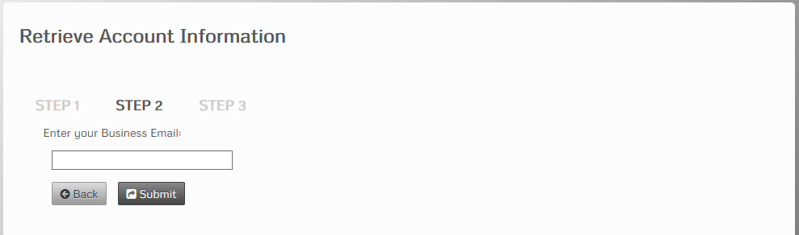

Updated: 4/22/2014

1. Read and follow the instructions provided on the final page of this wizard.

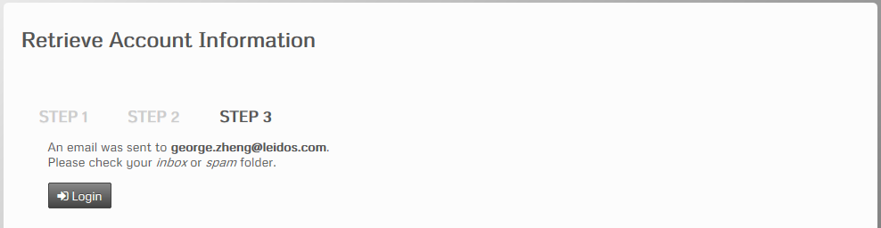

Updated: 4/22/2014

### User Registration Page

The User Registration Page allows a user register with the WxDE. The User Registration Page is shown below.

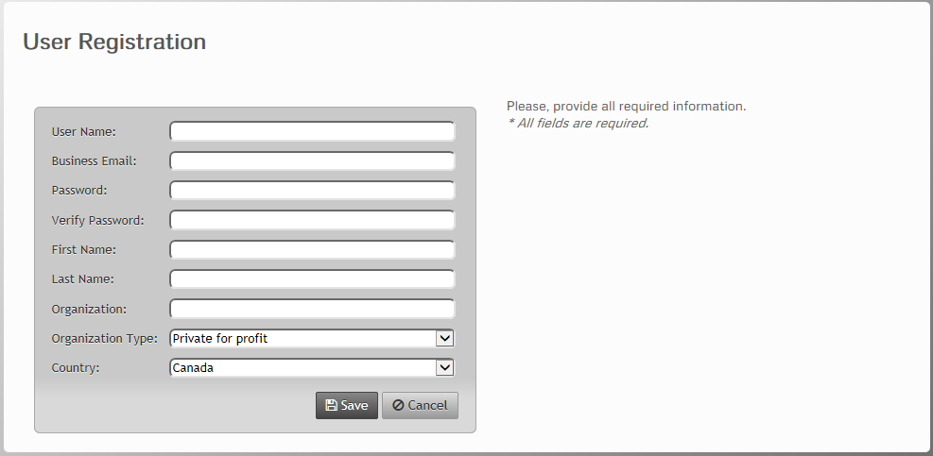

Updated: 4/22/2014

The user enters a user name, business email address, password, first and last name, organization, organization type, and country, then clicks on the Save button to save the registration information and create the user account. After clicking Save, a popup message (see below) notifies the user that registration succeeded, if the entered data is valid.

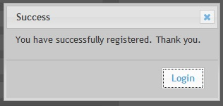

Updated: 12/31/2013

If invalid information is entered, an error popup message (see below) is displayed.

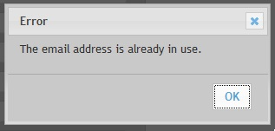

Updated: 12/31/2013

After a successful registration, the user also receives an email stating:

“Thank you for registering at Weather Data Environment. Click or copy the link in this email and paste it in your browser's Address Bar to validate your account: [url listed here]”

Clicking on the url brings the user to the WxDE page shown below:



Updated: 12/31/2013

### Logout

Selecting the Logout menu option logs the user out and returns them to the WxDE Home Page.